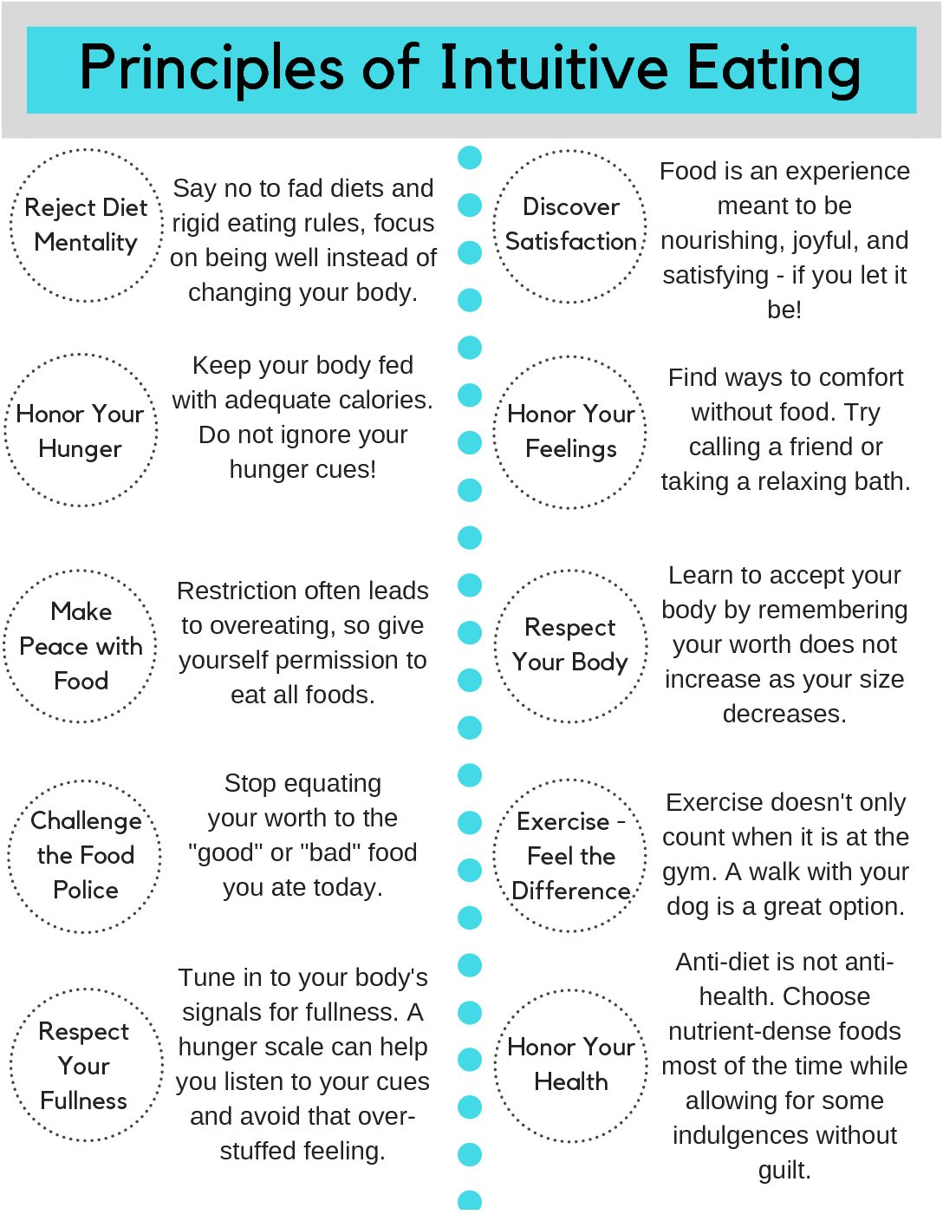https://www.health.com/nutrition/intuitive-eating

